JOUR 4251
Psychology of Advertising 4.1 Memory (continued)
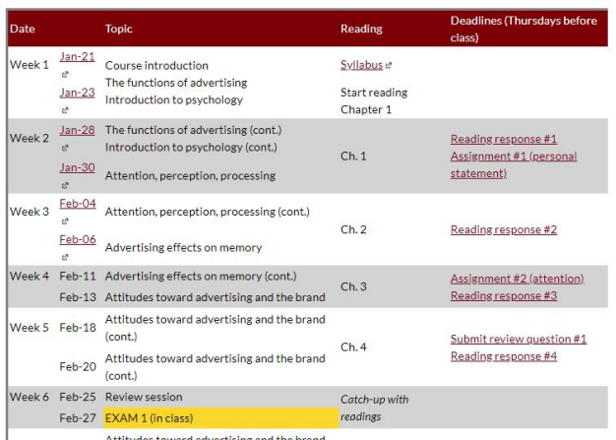
Recap Thursday
● Memory
○ Encoding
○ Storage
○ Retrieval
○ Forgetting
● Multi-store model of memory ○ Sensory memory
○ Short-term (working memory) ○ Long-term memory
○ Controversy
○ Depth of processing
■ Repetition is not enough
■ Semantic processing
Baddeley and Hitch model
Replaced the concept of short-term memory (working memory): Instead of one system, it was a multi-component system
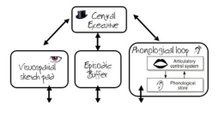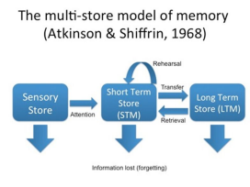
Baddeley and Hitch model
Replaced the concept of short-term memory (working memory): Instead of one system, it was a multi-component system
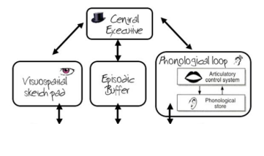
Central executive system
Controls a bunch of subsystems
Two subsystems are:
1. Phonological loop
2. Visuospatial sketchpad
Episodic buffer:
the place where info from long-term memory is integrated with working memory and manipulated. Where the brands live!
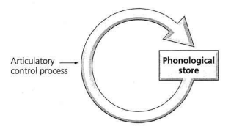
Phonological loop
Two parts
● Phonological store: holds sound or speech-based info ● Rehearsal system that uses “inner speech”
Limited amount you can remember
Visuospatial sketchpad
Brief storage and manipulation of visual information Spatial orientation
Solves visuospatial problems

Central executive
Allocates attention and coordinates the two systems
Focuses the available attention
No storage capacity: just manages how and where the information is stored

Episodic buffer
Integrates info from different sources
Limited capacity, temporary storage
Controlled by the central executive
Long-term and short-term memory can be integrated, manipulated Consumer consideration set lives here!
Consideration set
Number of brands from any given category that get referenced. All brands in a product category
All brands you are aware of
Consideration set
All brands you are
considering (to buy)
Baddeley and Hitch model

Replaced the concept of short-term memory (working memory): Instead of one system, it was a multi-component system
Central executive system
Controls a bunch of subsystems
Two subsystems are:
1. Phonological loop
2. Visuospatial sketchpad
Episodic buffer:
the place where info from long-term memory is integrated with working memory and manipulated. Where the brands live!
Long term memory
INFINITE
Composed of several departments
Distinction between:
● Conscious / explicit (declarative, recollective) ● Nonconscious / implicit


Explicit memory
Two types:
1. Semantic
● Organized knowledge you have about words and meaning ● Abstracted words and concepts and rules stored in your head ● Facts, ideas, meaning, and concepts
2. Episodic
● About an event that occurred at time and place ● Experiences, specific events
● Your memory about brand X’s new product
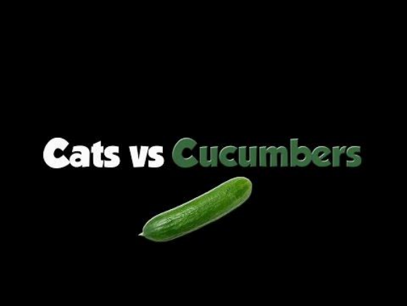
Recall versus recognition
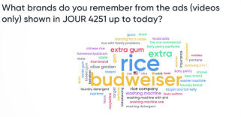
To measure explicit memory.
Three problems:
1. Explicitly remind people of
prior exposure
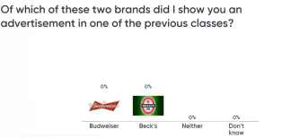
2. Question may make people
aware of researcher's
hypothesis
3. May not yield reliable results
Implicit memory
Exposure to ads: goes into implicit memory and you have no idea. Previous experience facilitates performance on subsequent tasks.
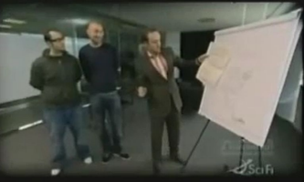
How do you measure something that
people cannot consciously remember?
Implicit memory measures
They measure whether people’s performance on a seemingly unrelated task has improved as a result of having experienced a prior event.
For example, people are NOT asked to recollect the words or ads they have previously seen, but they are asked to report the first word or brand that comes to mind.
Thus, implicit measures do not explicitly refer to a prior experience and do not require conscious or intentional recollection of this experience
Implicit memory
Word fragment identification task Brand name generation task Came up with as many brands
L_RP__ BU___R
as possible for product types during 45 seconds
Lexical decision task
WORD NON WORD Butter
Lexical decision task
WORD NON WORD Flweor
Priming
Refers to the phenomenon that exposure to an object or a word in one context increases the accessibility of the mental representation of that object or word
Supraliminal priming: priming task is conscious
Subliminal priming: priming task is nonconscious
This is how you can remember it:
Latin
Supra = above
Sub = below (submarine = below sea)
How is long-term memory organized?
Categories
Remember this is important for advertisers as they position their brands
Scripts
Sequence of events. What is supposed to happen here.
Scripts are different in some locations than others.
Examples: restaurant / store / bus
Nodes
Networked memory models
Print
Newspaper News
Article
Journalist Fake
Journalism Hubbard School of Journalism and Mass
Communication
Priming + network => advertising?
Increasing cognitive accessibility of brand names influence the inclusion of brand in consideration set, not purchase.
It influences brand choice (purchase) when:
1) Consumers have no particular preference
2) Preferred brand is not available
Forgetting the message
Memory fades with the passage of time
Competing information: new info can interfere with old information Factors that influence the effect of clutter on forgetting ads:
1. The person’s goal when processing the original advert and the new ones
2. Brand familiarity
Remembering the message Advertisers use lots of strategies to get you to remember:
● Retrieval cues
○ Same images as in advertisements (with variations) ● Repetition of advertisements and spacing:
○ considered a good strategy but really relates to attitudes not memory. Spacing the repetitions out will help recall.
● Primacy and recency effects
○ First / last commercial
What’s next?
The following things are due February 13 (before class starts!):
● Submit reading response 3 on Chapter 3 (memory) ● Assignment 2 (attention)
○ Hand in on Canvas: Upload Word/PDF document
● Let us know if you need a laptop for Exam 1
○ Email your TA
Also:
● Start reading Chapter 4 (attitude) when you have submitted RS #3. ○ Reading response #4 is due February 20 (before class starts)

